# ***Soccer League Algorithm***

* Derived from the League competition of football how teams play matches and try to increase their fitness at the end of each season.
* Total no of Matches played**: (M*(M-1))/2** where M is the total no of teams
* The Concept of SP & SSP(Star Player and Super Star Player)
* How fitness of the Solution is Calculated (Mean of the finesses of the Players)



* Base on the concept the fitness’s, probability of the teams to win or lose the match.

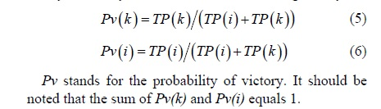

## ***4 Operators and roles:***

1. Imitation Operator

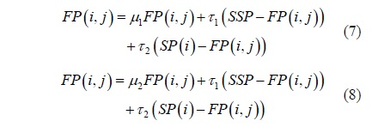

1. Provocation Operator

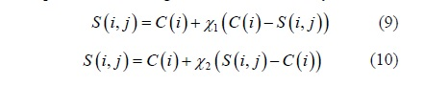

1. Mutation Operator

Same Concept used in genetic algorithm. Perform swapping of the positions of the solutions of losing team members.

1. Substitution Operator

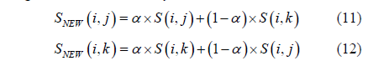

Total Number of Players= Total Teams*(Total no of fixed Players + Total no of Substitute players)

3<= NTeams <=5

Fixed Players=11

Substitute Players=1

## ***Pseudo code of the Algorithm:***

